Sheetless – gRADED UNIT PROJECT
Planning Phase Documentation

Dundee & Angus College
HND Software Development Year 2

Table of Contents
Client Brief 4
Aims of the project 4
Research 4
Application Features 9
Log-in Feature 9
Template Feature 9
Database Feature 9
Search Feature & Fault Detection 9
Exporting Feature 10
Device Compatibility Feature 10
Form Revision Feature 10
Requirements 10
Functional Requirements 11
Secure Log-in System 11
Template System 11
Database System 11
Device Compatibility 12
Search System & Fault Detection 12
Form Revision 12
Exporting 13
Non-Functional Requirements 13
System Usability 13
Time 13
Standards 13
Current System 14
Design 14
Likes 14
Dislikes 14
Resources 17
Hardware 17
Software & Tools 17
User Groups 18
Head of Production 18
Quality Assurance Leader 19
Production Associate 19
Project Developer 20
User Scenarios 21
Task Analysis 23
Assumptions 24
Constraints 24
Security Requirements 24
SQL Injection 24
Performance Requirements 25
Client-Side 25
Hardware Requirements 25
A Link to the Listing 26
Server-Side 28
Asset Log 28
Project Plan 28
Trello 28
Project Schedule 33
Milestones & Deliverables 34
Planning 34
Project Plan 34
Project Research 34
Resources 34
Diagrams 35
Implementation 35
Testing 36
Evaluation 36
Business Model 36
Activity Diagrams 36
System Login 37
Template System 38
Submit Traveller 39
Traveller Revision 40
Use Case Diagram 41
Sequence Diagram 41
Login System 42
Traveller Submission 44
Traveller Revision 45
Class Diagrams 46
Entity Relationship Diagram 46
CRC Cards 47
View Model 49
HCI 49
Visibility of System Status 50
Match between System and Real world 50
User Control and Freedom 50
Consistency and Standards 50
Error Prevention 51
Recognition Rather than Recall 51
Flexibility and Efficiency of Use 51
Aesthetic and Minimalist Design 52
Recognise, Diagnose and Recover from Errors 52
Help and Documentation 52
Wireframes 53
Data Binding 59
Bibliography 61

Client Brief
MEP Technologies Is a company based in Dundee that are known for their specialty towards the design and production and manufacturing of batteries and advanced battery systems for a wild multitude of use such as drones, robotics or electric vehicles. Whilst the company is known for the quality, they produce they have hired me to work upon updating and upgrading a crucial process of the production line that involves Traveller sheets. These sheets are used for logging each individual pack/unit that has gone through the production line from start to finish that involve logging each step as its completed successfully and is stored with the others in its kit. At the moment the process is manual which involves production workers to fill out each sheet for every unit that is worked on. Not only is this extremely time consuming but it’s wasting a lot of paper for these sheets to be printed and filled out just to be logged and stored away.
MEP Technologies has hired me to create and build upon for a better system as the current way is fully manual. The plan is to move to a completely digitalised system that would allow for production staff to log in and select the relevant traveller sheets that will automatically fill out the specific boxes that production staff would be doing. This would then take it to a database to be automatically stored from numerical order. Having a system handle most of the logging process will save production staff a lot of time that could be used on other crucial tasks for the day.

Aims of the project
This projects aim is to take the current paper-based system and transition it into a fully digitalised environment which could enhance worker/associate efficiency, use less paper and open more time for associates to work on other tasks/projects. Now the paper-based traveller sheet system is an extremely slow process that workers have to sit and fill out which at most could take hours. Moving to a digitalised and automated system will not only relieve them from the task but use way less paper in the process.

Research
After being hired by MEP Technologies, I had a sit down with the head of production at the company to figure out what the current system is, how it can be digitalised and improved upon to improve efficiency and take in any possible requests of features that they would like added to the application to not only make it easier for production staff but also include more functionality to the application. The meeting was scheduled for 02/02/2025 and was successfully completed and used to get a general idea of how the system could be created from paper to digital. Additional Meetings may be planned to ensure that implementation is to meet the requirements of the company.

Questions | Feedback/Answers
What is the current system? | On our current system that is being used right now in active production, all records of units and its progress through production is 100% manual through traveller sheets. These are in some way being logged manually in Excel however its extremely inefficient, time consuming and is less ecofriendly due to the amount of paper being used and wasted. Due to this, retrieving certain logged units is difficult as we must track down where in the workplace its stored to access its information which the digital app can make easier.
How are the traveller sheets being stored? | Current system is all being stored onto paper traveller sheets, these sheets are being bundled together in numerical serial number order and placed into a folder on a shelf. This in time takes up valuable space to be used for other things and could easily be stored in a digital system to be automatically sorted.
Is there a database/spreadsheet being used to track all the paper-based sheets? | Not at the moment. Currently there is no described database or relevant system being used to track the traveller sheets. With the current number of sheets being used and produced it is near impossible to categorise them all without taking time to pause production which can make our company lose money.
What Devices would this new system be accessed and operated on? i.e Mobile Phone, Tablet | The new system being proposed would hopefully be functional on most devices like Desktop Machines, Tablets or even optionally, Mobile Phones. Phones are not permitted whilst actively in the production line per safety regulations but the computer that associates use would work in this instance for logging sheets with this system.
At one time, if you could give an estimate, how many workers would you say could be using the application at one time? | On Average, there is around or approximately six workers that could be using the new system at one time, whilst considering individuals off work for their own reasons. Depending on the project or workload the number may be higher or lower each day. The digital system would have to be created with thought of allowing multiple users to access and use the system without issue.
What are the likes and dislikes about the current paper-based system? | The clients likes and dislikes of the current system and traveller sheets. This is not related to my own analysis and input on the traveller sheet design and manual system currently in use:  Likes  - Matching the traveller to the unit couldn’t be easier since it done physically by putting the paper next to the unit.  - Reliability, since it’s all manual, there’s no requirement or worry to the loss of data or progress via network connection or hardware failure. This also ensures that any/all disruptions to the production are prevented at all costs.  Dislikes  - Manual input, all data has to be put in manually by hand with a pencil or pen. Its severely time consuming than it would on a digital system. In the time it takes to fill these out an associate could complete another pack/unit.  - Due to the unit’s log being a piece of paper, there is a good chance that some may become lost in the production factory which could delay that unit’s progress in the production line and or add a delay towards that specific unit until it’s found, or a new one is created for it.  - Paper Waste, the amount of traveller sheets that accumulate through the years that are just used once to track the unit then stored away is extremely high, this has a bad impact for the environment and could be erased with the new digital system.
Near Project completion, how do you expect the new system to fit into the current production process? | At the point of project completion, the new digital system is planned to be ran with the old paper-based system. This would consist of the testing phases to see how more efficient it would be against the current known system.  This will work in line with the old system therefore if there are any issues then production progress won’t be delayed.  At the end of the testing timeframe agreement set out by the developer and management feedback will be gathered to investigate if the new digitalised system is more reliable and more efficient than the paper-based system, if this is true then the old system will be gradually concluded.
How many kinds of Traveller Sheets are there just to get a scope of how many options to provide? | Currently at the time of this meeting, each project has its own unique traveller sheet which is attached to its unit. As previously explained, there are paper based which the new system may/would have to accommodate many variants of to ensure that each project works as expected in production.  Due to the amount of projects we work on, there is no definite number of traveller sheets that are actively used, some projects may be phased out in time so their traveller sheet will be irrelevant.
Should certain job roles have more levels of access in this new system, or should everyone have the same level of access? | Not initially for the build travellers, at time of development everyone will have the same level of access.  Only thing that would need to be locked would be final inspection so no one can make a change.  When developing the system, all users would have the same level of access into the system therefore all active staff can use the system and provide its crucial feedback on the process with some exceptions to ensure that all data is protected.  Specifically, as a request, the final inspection stage of the unit’s production process should have restricted access to prevent any and all unauthorised changes to that unit and its traveller sheet. Access in this stage should be limited to Quality Assurance Leadership or Management.
Additionally, what user groups would be using the application on a regular basis? | Associates, Quality and Management Team. All sorts of alternate job roles and positions may be using the system implemented.  Associates, Use the system from start to finish in the production line to complete a unit. Associates fill out required fields that they have completed such as:  - Loading Battery cells into packs  - Weld pack in the manual/auto welder  - Soldering Connections  - Case the Pack  - Clean the pack  - Package the pack onto the pallet  Quality Assurance Would be covering sections relating to unit/packs to ensure that the overall production quality is as high as possible. They may at any point designate a unit as a failure or fault to take it off production line to investigate the unit in question.  Management Team involves Managing Director, Supervisors, Head of Production & Head of Stock Room. Management will oversee the production from start to finish to ensure it is done correctly and safely. Management will also oversee traveller sheet designs and may change/alter them if necessary.
In the new digital system, should it follow the same format/layout as the sheets, or would it be different/simpler? | At the time of implementation, the digital system should follow or closely resemble the current paper-based traveller sheet design and format. Each sheet goes through extensive discussions with all management team members for the end result to be approved by all members. This ensures that the active sheet being used is correct in all aspects for production and safety.  Using the current paper-based traveller sheet layouts will assist the current employed staff easily move over to the new system as it’s the layout they know how to use from the previous manual system.
Are there any specific security requirements for the application to be accessed in the workplace? | Mainly the only security measure that I can currently think of would be the timeframe of the quality assurance sign off, once this is completed the traveller sheet entry should and must be locked down to prevent any kind of modification. This ensures that units that are awaiting inspection are not altered after the inspection process.  Down the line of development, we may consider the implementation of other measures of security like  - Role-based access, some roles within the workplace would have other access methods like exporting to Excel or accessing the overall database.  - Login, Initial log into the system would either require a unique worker id or a single workplace logon for the whole production line. This would assist in ensuring that any unauthorised access is prevented.
Should all Traveller Sheet data be stored in the database, if so for how long, Permanent or Temporary? | Yes. It would and should be stored in the database as a permanent place for the unit information. This will ensure that a unit and all of its crucial information can be traced easily and efficiently in any case of fault or alternate reason.
Would the application have to follow any specific colour scheme, like Logo colours etc? | In a design aspect, the digital system does not need to follow any strict design or colour scheme. As long as our company logo is branded on the system that would be fine for us. Preferably the design should be considered with the aspect of readability and usability for our workers and office staff.

Application Features

Log-in Feature
- Secure Log-in System would allow for production staff and management to easily and swiftly log into their accounts to access the MEP Technologies system. Each staff could have specific data linked to their account that the system will indirectly know what parts of traveller sheets should be filled in and what should be left blank. This would allow for each worker to use the system as intended based on what they do in the production line. The Login System could hold other information such as ID Badges to get into the building or ID Images.

Template Feature
- Upon logging in the end user would be met with a template screen, this would hold all the alternate Traveller sheets for other battery production projects. The end user/worker would click on it, and it would load into a new page with that sheet chosen. Whether its clear buttons or a search function to get into the specific templates all possible design options will be considered before implementation. Templates could have a little information added to it to ensure that they select the correct one. Adding onto this feature, the system will handle most details automatically but when the digital traveller sheet is complete, the worker can then click submit to send it to the database to be logged.

Database Feature
- A Database will be directly connected to this application. Any Traveller sheets that have been completed will be sent to this database and shall log all relevant information such as Submitted by, Date Submitted, The Unique ID Number linked to that sheet along with the digital traveller sheet itself with the workers data inside it. To meet with digital standards the database will be protected against all modern attacks against it like SQL Injection which could cripple a database if not created securely.

Search Feature & Fault Detection
- When talking to the client it was mentioned that an extremely useful feature in the application would be a way to search for or filter a unit’s traveller sheet for potential faults that may come across in the manufacturing and production process. The feature would possibly come into the templates that the worker would have to add themselves to be sent to the database. The feature would have to be simple enough for management to search against to locate the specific traveller sheet and unit that its connected with to take off the production line and investigate on how its faulty.

Exporting Feature
- Exporting, upon talking with the client there was a request, if possible, to have a feature that would take the Database at any point and export it to Microsoft Excel for further logging of all packs completed during the production process. This request comes as it would not disrupt current operations of Storeroom Management with having to move to a completely new system whilst still manufacturing battery units/systems.

Device Compatibility Feature
- Alternate view on other devices, per regulations within the workplace you are not permitted to actively be on your phone whilst in the production area as this could not only be a safety hazard but also ensures that you are not distracted when operation crucial machinery or equipment. Talking to the client found that having tablets on site would be acceptable to have as they can be used for specific purposes in the workplace and such the application may hold compatibility for both devices in their respective screen resolutions to meet these conditions.

Form Revision Feature
- At request of the client, a feature that will allow management/leadership to easily decide and change over to a new traveller sheet layout/format. This process involves each member of management to vote on the new layout based on its requirement needed for standard production. Once each management member has approved it, it will then be moved over to the official branch of the traveller sheet template on the system.

Requirements
With the discussion with the Client, Additional Functional and Non-Functional Requirements have been implemented here based on meetings that have prior taken place.

Functional Requirements
Function Requirements Following a Traffic Light System in priority:
- High Priority
- Medium Priority
- Low Priority
Secure Log-in System (High Priority)
A Login system would allow for the system to be more secure by only allowing a select group of individuals into the system that it was intended for, in this case would be the employees of MEP Technologies. A Log in system is expected to:
- Allow Authorised Employees to access the specific system without issue thus not disrupting workflow
- Block any unauthorised log-in attempts to the secure system. i.e Anyone that does not work with the company or its partners.
- Log-In System is expected to meet security requirements and standards which would include protection against the likes of SQL Injection or other forms of malicious attacks in order to gain entry.
Template System (High Priority)
A Template system would allow for the ease of access to all the various traveller logging sheets that MEP Technologies uses for its daily production processes. The template system would work in a way that when logging into the system it provides the worker with its choice of traveller sheet for the specific project they are currently working on.
The Template System is expected to:
- Provide the end user with a selection of traveller sheets for the respective project, either allowing them to search for it or hiding the travellers that the worker would not be working on for easy discovery.
- Traveller sheets that have been selected by the end user is expected to auto fill out the respective data such as the current date of the day being viewed.
- Optionally provide a logging system that shows data of when a traveller was uploaded to the database and what time it was uploaded followed by a reference number for easy of discovery. This feature could make it into final build given no time constraint issues.
Database System (High Priority)
A Database can be used in various ways that could be beneficial for countless implementations or projects. A Database is planned to be connected to this digitalised system that would store the traveller sheets that are submitted by Production staff through the production line.
In this project of moving a paper-based system to digital, a database would prove to be extremely useful for the traveller storage. All the traveller sheets being generated have to be stored somewhere, a database will be the place that all the sheets and its relevant information and data are stored in. Such additional information stored with the database via fields could be Traveller Unique IDs for simple searching or Exact date and time it was submitted.
Device Compatibility (High Priority)
Device Compatibility is very important when considering a system that is being created for browser use, this will allow for the system to be viewed on any device or resolution which adds to its responsiveness. Per MEP Technologies Regulations, Mobile phones are prohibited from being used in the Production Area due to possible distractions near heavy machinery, this measure is in place with safety in mind as a number one priority. The system at hand will be planned to be used on a desktop resolution with Optionally Tablet view given no time constraints near the end of development.
Search System & Fault Detection (Medium Priority)
The thought of a search function in theory is a simple addition that may not provide any assistance however this is incorrect. A Search function is extremely useful when trying to locate a specific unit or traveller sheet especially when you are dealing with thousands of entries. This also works in line with a fault detection system that would allow the production staff or management to look up a unit and investigate what the fault is, retrieve the traveller sheet and pull it off the production line. A Search function is an extremely important function that improves overall user efficiency by speeding up the task process. Such other uses of this important implementation are:
- Accessibility, easily access any traveller sheet by searching through the database with its unique identifier, an associate can easily access and retrieve the traveller sheet and its contents in a timely manner quicker than how long it would take in the manual system.
- In the event of a faulty unit, the search functionality can swiftly locate the unit in question and pull it off the production line for closer inspection by Quality Assurance and Associates.
Form Revision (Low Priority)
After discussions with the client on requirements, per request they would like an addition that would allow the management staff to easily swap over to a new revised version of a traveller sheet. This process undergoes critical decisions with each member of staff to ensure that the revision is required, necessary and important. Once the new layout is approved by all managers the traveller sheet format revision will be integrated into the digitalised system for all workers and staff to view and use. The Client has confirmed that this addition is implemented based on time constraints near the time of its implementation.
Exporting (Low Priority)
Export feature per request from the client to be implemented based on no time constraints in development, Export feature would function in a way that would allow management or Stock room staff to Export the database into other formats like Microsoft Excel, this is currently used for all stock logging and would help the company with not disrupting current active operations. The export function is expected to:
- Allow stockroom staff or other associates to export the data into another format for continued logging.
- Not disrupt current production and logging processes.
- Avoid unnecessary design choices in the exporting feature to allow for staff to export the data they require as soon as possible.

Non-Functional Requirements

System Usability
- All Developed systems should be created and designed with usability in mind, providing the end user with the best experience with user friendly designs is crucial for a well create application/system. Other aspects of Usability can be covered in Jakob Nielsen’s 10 Heuristics of Usability.

Time
- Planning Phase Documentation should be completed by 24/02/2025 to make sure that all areas of development are covered and planned to ensure project success within its deadline.
- Development Phase should be completed by 21/04/2025 the time given should be enough time for development, testing and fixing of any issues or changes per client request or feedback.

Standards
- Source Code for the system should be professionally commented to meet modern code standards.
- Methods/Variables should be named correctly with use of conventions like camelCase
- Front-end Designs should be created to be user friendly with minimal white space with considering UCI.

Current System
Currently the system used at MEP Technologies is fully dependant on using individual paper sheets known as ‘Traveller Sheets’ To log a pack/unit’s progress through the production line process. The current system has production staff filling out the sheet with each task completed along with full names and the date it was done.

Design
The following image(s) are of the paper-based Traveller Sheet System in reference to the prior documentation. After speaking to the client, I was given permission to include the workplace traveller sheets in the document:

Likes
- Company logo makes good use of colour which stands out to the naked eye. Digitalised application could follow the similar colour scheme to match the company logo to display nicely.
- Each unit has a very specific serial number that would go with the sheet in order to exactly pinpoint it later in the production line if any errors were to be located. This is a good system to have in place for ease of access, especially when dealing with hundreds of battery packs mid-way through production of that kit.
- Simple Design, the traveller sheet is a minimalist design which consists of a carried out by and checked by following with the date it was completed at system. It is somewhat easy enough for a new production worker/associate to pick up and use.
- Jargon used on the traveller sheet is simplistic and informative for the workers to understand based on the tasks being performed at the workplace.

Dislikes
- Lots of white space/ unused areas on the traveller sheet, this could be used to hold more information / have bigger boxes for input.
- Can seem quite complex to the average individual / someone who just started working with the company, especially in the back of the traveller sheet with the voltages of the unit that is being produced.
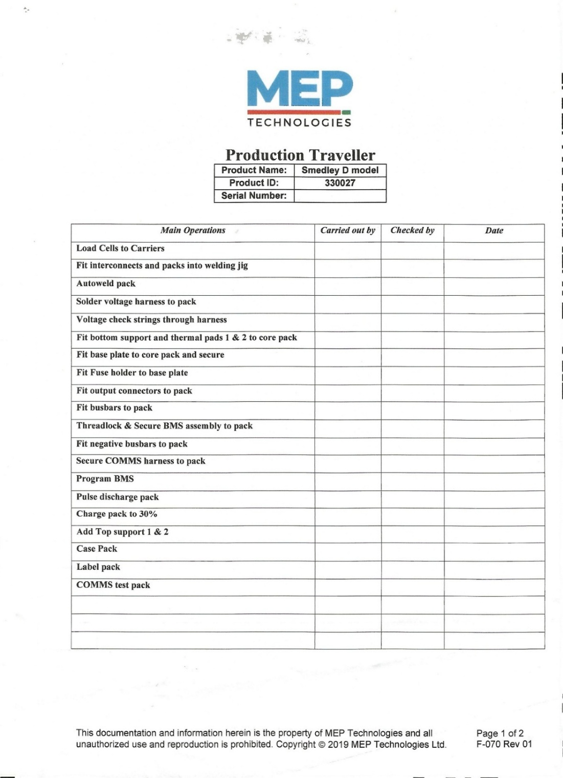
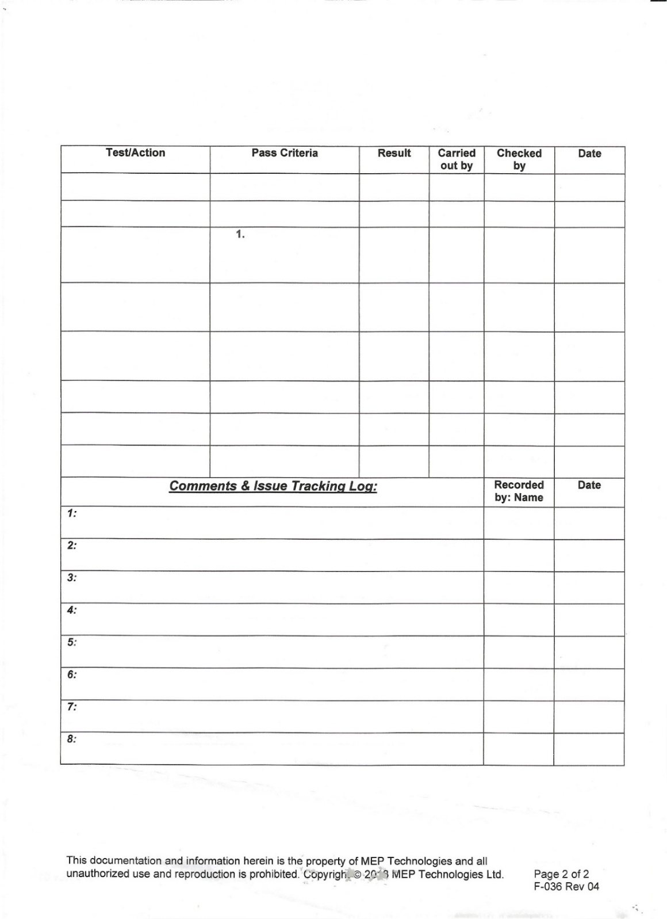

Resources

Hardware

Laptop Specifications
Ongoing Planning and development will be done using this laptop when not at
- 12th Gen Intel(R) Core(TM) i5-12500H
- 16GB DDR4 Ram
- 500GB Solid State Drive
- Windows 11 Pro Operating System (64bit)

Desktop Specifications
- AMD Ryzen 7 7800x3D
- NVIDIA RTX 4070 Super Graphics Card
- AMD Integrated Graphics Alternative
- 32GB DDR5 Ram
- 2TB M.2 Solid State Drive
- 1TB M.2 Solid State Drive
- Windows 11 Pro Operating System (64bit)

Client Desktop Specifications
- 14th Gen Intel(R) Core(TM) i5-1440F
- 1TB Hard Drive
- Intel Integrated Graphics
- Windows 10 Pro Operating System (64bit)

Software & Tools
- Microsoft Word
- Microsoft Snipping Tool (Laptop)
- ShareX Snipping Tool (Desktop)
- Visual Studio Code
- XAAMP
- Trello
- NinjaMock Wireframe Tool
- Draw.io Diagram Tool
- SmartDraw Entity Relationship Diagram Tool

User Groups

Head of Production
Relationship | Client of this Project, Manages MEP Technologies Production.
Key Goals | - Manage overall Production and Production Staff Workloads  - Ensure all Units are being Constructed currently.
Characteristics | - Male, around 40-50 Years Old  - Has Expert Knowledge in the profession of Battery Production and Safety.
Tasks | - Actively Manage and oversee all active operations in MEP Technologies.  - Work in line with Production Staff to ensure projects are moving smoothly.  - Schedule Regular Meetings with Managing Director, Quality Assurance to discuss Project updates, progression and other company matters.  - Oversee Stockroom logging system ensuring that all Stock is listed which includes deliveries and shortages of certain stock items.  - Be in contact with new clients to the company, hold meetings with them to ensure that MEP Technologies is able to provide the services they require.
Constraints | - Simple and Readable design.  - Simple Colours and Appropriate Font Usage.
Technical Environment | - Desktop, Laptop – Both Devices use Microsoft Windows 10 Pro.  - Both Devices have an unknown set of System Specifications.
Physical Environment | - Indoor Environment  - In an Office with a Desk  - Has an alternative Desk in the Stock Room to easily manage stock levels without leaving stock room.

Quality Assurance Leader
Relationship | Client of this Project, Manages MEP Technologies Production.
Key Goals | - Oversee All Production Quality.  - Ensure All Products Created Meet Quality Standards.  - Ensure that Production Staff are meeting Safety regulations.
Characteristics | - Knowledgeable in technology and successfully trained in the use of the Machines Used in the Company.  - Male, 40-55 Age Range.
Tasks | - Work in line with Production Associates, Head of Production and Managing Director to ensure overall quality is at a reasonable level.  - Attend Regular meetings held with Head of Production & Managing Director.
Constraints | - Simple Colour Scheme, easier to read.  - Font Choices that are readable.
Technical Environment | - Desktop Computer, Windows 10 Operating System, Other Specifications are Unknown.
Physical Environment | - In Office with a Desk using a Desktop Machine.

Production Associate
Relationship | Associate works on Projects at MEP Technologies within the Production Line, expected to work with Supervisors & Head of Production.
Key Goals | - Work with Head of Production to ensure active workload is meeting standards with the company  - Actively work on Battery Unit production in the production line.  - Making sure that all traveller sheets are being filled out as expected.
Characteristics | - 20-27 Years old Male & Female.  - Semi-Knowledgeable in technology.
Tasks | - Actively Produce Battery Units.  - Complete tasks given by Head of Production.  - Fill out, log and categorise Traveller sheets.  - Clean Packs/Units.  - Await Quality Assurance Leader to Inspect the final Units Product for overall Quality.  - If passed by quality, Package the Units up into boxes and place them onto the delivery pallet.
Constraints | - All content should be readable including Font and colour scheme usage.
Technical Environment | - Shared Desktop Machine in the Production Line, Windows 10 Pro, other specifications are unknown.
Physical Environment | - Working in the production line, Shared Desktop Machine for certain tasks.

Project Developer
Relationship | Coordinates with Client to ensure Project is created as expected, Developer will Plan Create, Develop, Test and Submit the finished System to the Client.
Key Goals | - Work with the client.  - Actively create valid documentation to allow the client and developer to understand the project, how it will be developed and at what stage of the development it is currently in.  - Documentation provided to the Client could be in a form of User Guide, it allows for someone with no previous experience with the system at hand know how to use it step by step.
Characteristics | - High Knowledge on Technology  - Knowledgeable on the requirements of the company for the specific Project they are working on
Tasks | - Work with Client to ensure project progress is on track.  - Actively Develop the System being proposed to the client.  - Successfully Document the whole planning, Development & Evaluation Process.  - Generate Relevant Diagrams that show relationships based on the project and its client.
Constraints | - Hold Meetings with the client to research and investigate more about MEP Technologies and how they handle Production Processes.  - Ensure All steps of development is planned to ensure enough time is given to develop the system.
Technical Environment | - Desktop Machine, Specifications:  - AMD Ryzen 7 7800X3D  - NVIDIA MSI RTX 4070 Super  - Microsoft Windows 11 Pro Operating System (64bit)  - 32 GB DDR5 Ram  - Lenovo V15 15.6 Inch Laptop For out of home office use, Specifications:  - Intel Core i5-12500H (12-Core) Processor  - 16GB DDR4 Ram  - 512GB Solid State Drive  - Microsoft Windows 11 Pro Operating System (64bit)
Physical Environment | - Home, Office Environment with a Desk on a Desktop Machine  - Workplace Environment with a Desk on a Laptop

User Scenarios
Scenarios Based upon Production Associates / Staff at MEP Technologies using the “Smedley D Model” Project Traveller Sheet. Alternative Projects and their respective Traveller sheet may be implemented at request of the Client in later stages of development.

Logging into the System
The Production associate would turn on the workplace computer, log into the account for Windows using the workplace login credentials set out by the IT Staff. They would then navigate to their browser of choice to access the system. The website would prompt the end user to enter login credentials, this would be one shared login credential for the whole production staff. Entering the correct login credentials would gain them access to the system prompting them onto the traveller template page. If the login credentials were incorrect on sign in attempt, the system would prompt an error and to try again.

Choosing a Template
The end user would turn on the workplace computer, log into the account for Windows using the workplace login credentials set out by the IT Staff. They would then navigate to their browser of choice to access the system. The website would prompt the end user to enter login credentials, this would be one shared login credential for the whole production staff. Entering the correct login credentials would gain them access to the system prompting them onto the traveller template page. Upon the template page, they will be met with numerous traveller sheets for a range of projects being produced at MEP Technologies, The Production Associate then chooses the “Smedley D Model” Traveller Sheet. The system recognises this and takes the sheet and the user onto an edit page to fill out the data onto it.

Editing the Traveller
Upon the end user picking the Smedley D Model Traveller sheet, the system will move over to an edit page for that traveller sheet. It holds all information relating to the traveller, its unit and its whole processes throughout the production phase. The system will automatically fill in the date into the sheet based on the day it currently is being viewed and edited on. The end user moves over to select the processes they have worked on by clicking the check box for each section, the end user then clicks the Confirm button to lock in that version of the edited document.

Submitting The Traveller
Once the associate has confirmed the edited traveller sheet is complete, it is then submitted. The System then will take this edited revision of the traveller sheet and upload it to the Database connected to the system, the database will upload all relevant information and data of the traveller sheet to be permanently stored and logged in numerical order.

Task Analysis

Logging into the Digital Traveller Sheet System
- Turn on the computer.
- Log-in to the Operating System.
- Load into the System onto the Desktop.
- Navigate to a browser of choice.
- Navigate to the system via browser.
- Enter Login Credentials.
- Click “Log-In” Button.

Picking a Traveller Sheet
- Turn on the computer.
- Log-in to the Operating System.
- Load into the System onto the Desktop.
- Navigate to a browser of choice.
- Navigate to the system via browser.
- Enter Login Credentials.
- Click “Log-In” Button.
- Load into Traveller Home Page.
- Search for “Smedley D Model”.
- Click The Traveller.
- Load into Edit Mode for that Traveller.

Editing Traveller Sheet
- Turn on the computer.
- Log-in to the Operating System.
- Load into the System onto the Desktop.
- Navigate to a browser of choice.
- Navigate to the system via browser.
- Enter Login Credentials.
- Click “Log-In” Button.
- Load into Traveller Home Page.
- Search for “Smedley D Model”.
- Click The Traveller.
- Load into Edit Mode for that Traveller.
- System allows Associate to insert its data to the system with ease.
- Associate Finishes editing the document and moves to click “Confirm”.
- System provides the end user with a preview of the edited document with a “Submit” Button.
- End user clicks “Submit” to send it to the database.

Assumptions
- Users of the System will have somewhat fundamental knowledge of technology and how to use a computer efficiently.
- The Operating system used on the computer is Windows 10 Or Higher i.e Windows 11, Older Operating System versions may prove unresponsive or not work as intended.
- Users of the system know the fundamentals and have training behind what sections of the traveller sheet they must fill out and which they must leave blank.
- Head of Production should understand how to perform tasks such as exporting to excel via the feature requested on meeting.
- If the system is proven to be unresponsive or unusable, the users should know to use the paper-based system as a backup for hardware/software failure.

Constraints
- Users with a smaller knowledge on technology may need more time to understand and learn the new digitalised system.
- Users of the system may not remember the shared logon password and may need to talk with developer or IT Staff to get into the system. An additional contact option may be required on log on for assistance.
- Project Deadline is on the 21^{st of} April 2025, this could be a tight timeframe to develop, implement and test the system being proposed. Given timeframe in development there may be a chance some suggested features may be left unimplemented or may be not functional as intended.

Security Requirements

SQL Injection
SQL injection is a security vulnerability that could allow a malicious actor/attacker to use or manipulate your SQL Database for their own benefit using queries either in the system itself or a website that is connected to it. SQL Injection can also allow actors entry into applications or systems they should not be able to access which could put all data within at risk. SQL injection does also have exploits that would easily bypass security measures put in place by developers of the site/system putting personal data, company data and information at risk of being compromised, tampered or deleted.

Performance Requirements

Client-Side
- Operating System, Windows 10 Home at a Minimum, this prevents any unexpected issues for the clients view when using the System. Windows 10 Is set as the minimum due to other Operating Systems not being supported by Microsoft Anymore such as Windows 7, Windows 8 etc.

Hardware Requirements

Central Processing Unit (CPU)
- Minimum CPU, Intel Core i3 10 Generation Processor, (Intel Core i5 12th Generation Recommended) or for an AMD Equivalent, AMD Ryzen 3 3100/3300X (Recommended, AMD Ryzen 5 5600), both processors should handle the system with not issues, at a minimum the system will be able to function as expected.

Random Access Memory (RAM)
- Minimum RAM, 4GB (8GB RAM Recommended). Would allow for most systems with these hardware specifications to complete any task with no issue, Computers are starting to become more demanding, a few years ago 4GB would be the recommended. The System being created may same less demanding but to be safe with the amount of data that may be storing onto the browser its better to be safe.

Storage
- Storage, at a minimum 2GB Free space (256GB Hard Drive Recommended), the usability of the system and site should be as smooth as expected. The Storage capacity would only fall under a consideration for when/if Head of Production decides to export the database which depending on the amount of data being exported, could increase the file size. I recommend a 256GB Hard Drive as they are cheap for the amount of space that comes with it, Possible usability could make use of Microsoft OneDrive to fulfil space requirements.

Computer Recommendations
This Computer has all the specifications as previously displayed above, this would work as an efficient computer to be used within the Production Line for Production Associates to add, remove and edit traveller sheets. The All-In-One Computer would be perfect for the Production Line environment as its space efficient due to it being compact into one space meaning it can be placed nearly anywhere without disrupting the flow of the workplace and active production.

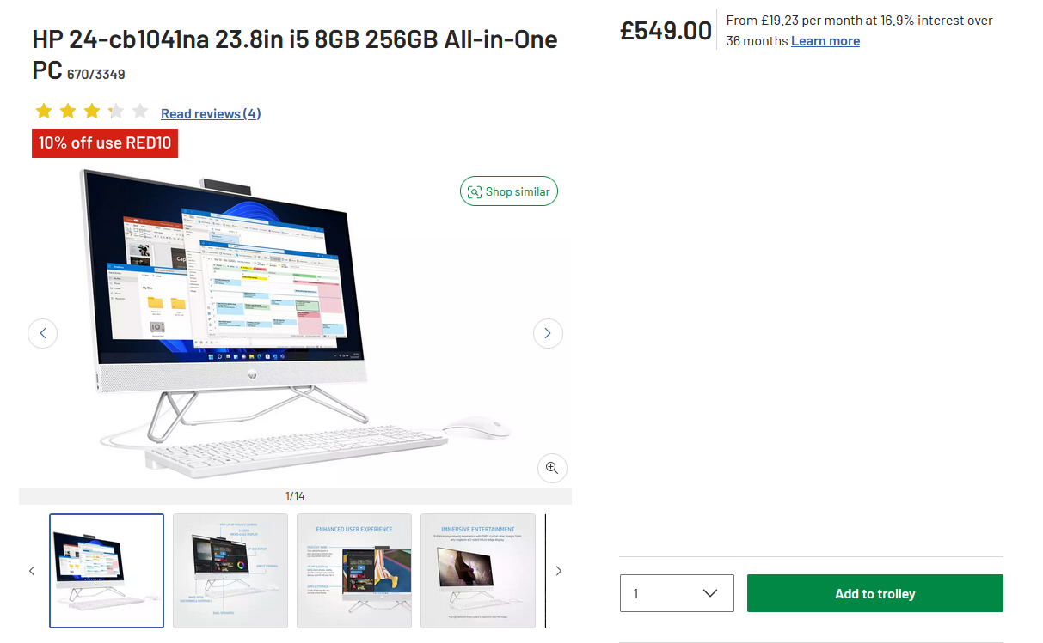
A Link to the Listing:
https://www.argos.co.uk/product/6703349?istCompanyId=a74d8886-5df9-4baa-b776-166b3bf9111c&istFeedId=c290d9a9-b5d6-423c-841d-2a559621874c&istItemId=mxxraxrta&istBid=t&utm_custom6=PLA&utm_source=google&utm_medium=free_listing&utm_campaign=merchant_center&gPromoCode=RED_10_&gQT=2

Computer Specifications
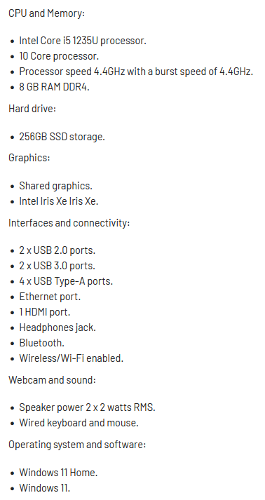
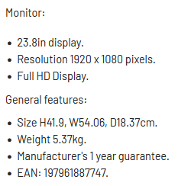

Server-Side
- Response Time at a minimum 1-2 Seconds, this provides ample time for data to be retrieved from the systems and databases to be displayed. At most, this will be the usual speed for any form of processing for the system.
- Database Processing, Such SQL Queries that may be processing travellers submitted to the system may take some time to complete, with specifications recommended, it is expected to be completed within 1-2 Seconds. This ensures that the experience the end user receives is the best possible. Ensuring that these processes are completed as quick as possible allow for more time to be spent efficiently within the workplace and or system.

Asset Log
File Name | File Type | File Extension | File Size | Description | Asset Image
MEP-Tech-Logo | Image | PNG | 3.99KB | MEP Technologies Logo Provided to use with Permission from Client | 

Project Plan
The main tool used for planning is Trello, tasks are aligned here with due dates and labels that correspond to their respective sections. Trello will be useful to keep on track to meet overall project deadlines, any new tasks created throughout the development will be added and implemented to the Trello accordingly.

Trello
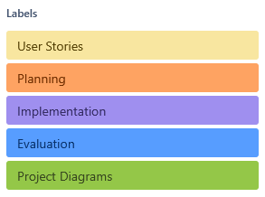
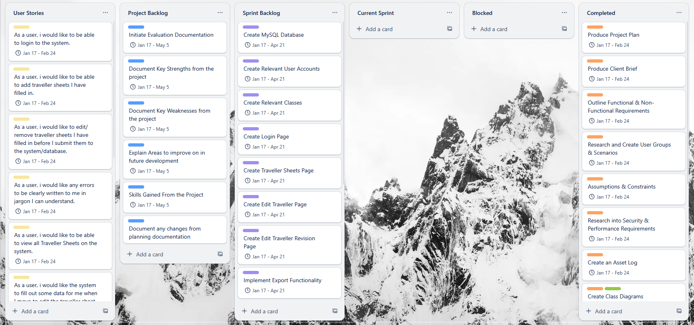
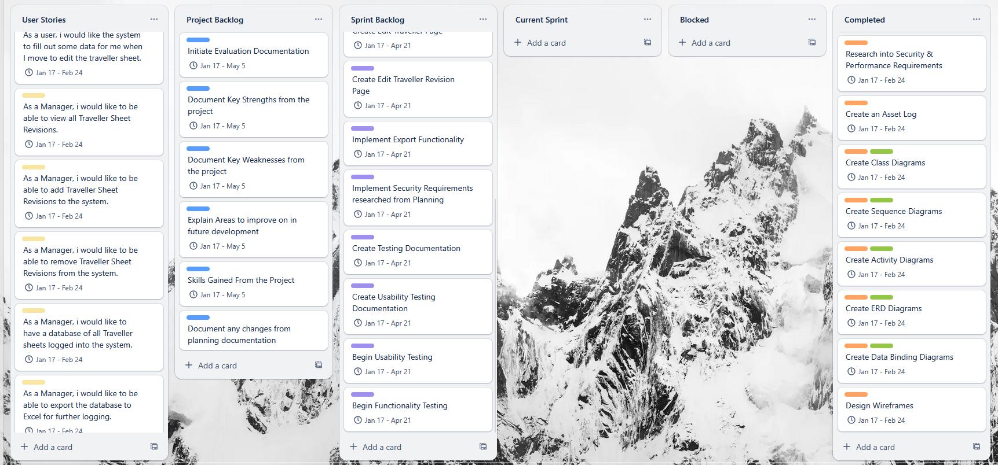

Planning
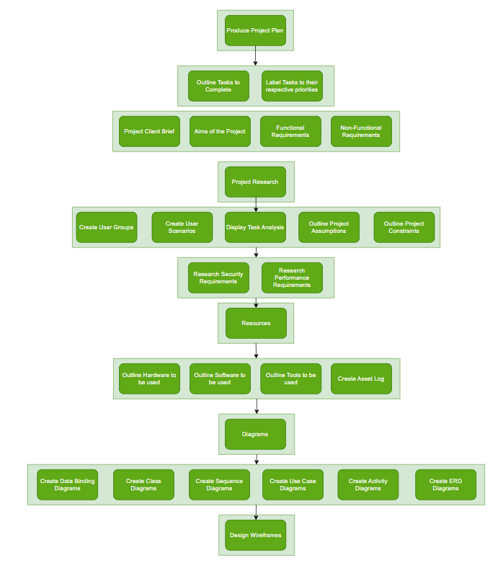

Implementation
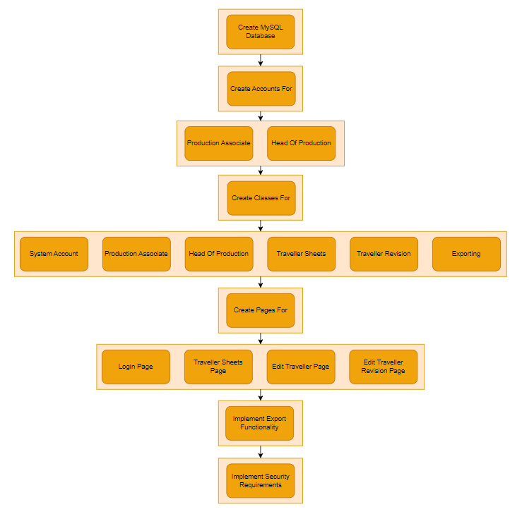

Testing
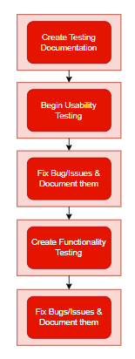

Evaluation
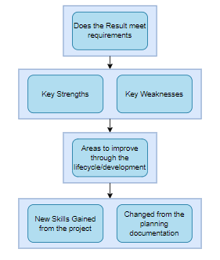

Project Schedule
Weeks | Planning | Implementation | Testing | Evaluation
Week 1 | Create Project Plan
Week 2 | Create Client Brief, Functional & Non-Functional Requirements
Week 3 | Schedule Meeting with Client
Week 4 | Produce Relevant Diagrams
Week 5 Project Planning Due | Finish and Submit Planning based on marking Scheme  Transitioning to Implementation | Create MySQL Database for the System &  Implement Security Measures to System for the Database
Week 6 |  | Visualise Page Designs relevant to Wireframes
Week 7 |  | Implement High Priority Requirements
Week 8 |  | Implement Medium Priority Requirements
Week 9 |  | Implement Low Priority Requirements
Week 10 Testing Phase |  | Transitioning to Testing | Begin Testing against all Systems against a testing plan
Week 11 |  |  | Fix any bugs or issues found from test cases
Week 12 Implementation Phase Due & Testing Phase Due |  |  | Finalise & Complete Implementation & Testing
Week 13 Project Evaluation Start |  |  | Transition from Testing to Evaluation | Produce Project Evaluation
Week 14 Project Evaluation Due |  |  |  | Submit Project Evaluation

Milestones & Deliverables

Planning

Project Plan
  - Research into a successful and useful project plan that fits with the current project and its requirements
  - Once Tasks have been discussed with a client meeting, schedule them appropriately

Project Research
  - Create User Groups
  - Create User Scenarios
  - Display A Task Analysis
  - Outline Project Assumptions
  - Outline Project Constraints
  - Identify Functional Requirements
  - Identify Non-Functional Requirements
  - Research Security Requirements
  - Research Performance Requirements

Resources
  - Outline Hardware being used in active planning, implementation & Testing within the Project
  - Outline Software to be used in active planning, implementation & Testing within the Project
  - Outline Tools to be used in active planning, implementation & Testing within the Project
  - Create and display an asset log of material to be used within the Project

Diagrams
  - Create Class Diagrams
  - Create Sequence Diagrams
  - Create Use Case Diagrams
  - Create Activity Diagrams
  - Create Entity Relationship Diagrams
  - Create Data Binding Diagrams
  - Design Wireframes for prototype design

Implementation
- Create a MySQL Database for:
  - Traveller Sheet Logging
  - User Accounts
- Create Accounts for:
  - Production Associates
  - Head Of Production
- Create Classes For:
  - System Account
  - Production Associates
  - Head Of Production
  - Traveller Sheets
  - Traveller Revision
  - Exporting
- Develop Pages and content of:
  - Design & Create Login Page Layouts based on Wireframes
  - Design & Create Traveller Sheet Page Layouts based on Wireframes
  - Design & Create Edit Traveller Page Layouts based on Wireframes
  - Design & Create Edit Traveller Revision Page Layouts based on Wireframes
  - Design & Create Export Database to Excel Functionality
- Implement Security Requirements to the system based on prior Planning Documentation of:
  - SQL Injection
  - Login System Security

Testing
- Create Usability Testing Documentation
  - Any Fixes or Changes in this period should be fixed as required.
- Create Functionality Testing Documentation
  - Any Fixes or Changes in this period should be fixed as required.

Evaluation
- Does the result meet the initial project requirements?
- Final Research on:
  - Overall Key Strengths
  - Overall Key Weaknesses
  - Any Areas to improve on throughout the development lifecycle?
- Document Any achieved new skills or knowledge from completing the Project
- Document any future additions if development were to be continued in the future.
- Document and explain all deviations from the initial Planning Documentation

Business Model

Activity Diagrams
Activity Diagrams provide a simple to follow graphical representation of the general flow or direction of a system. The following Activity Diagrams show a thorough representation of the process the end user goes through with the system being proposed. The Activity Diagrams showcase a fair number of scenarios as seen below which can be used to visualise how the system will be once implemented down the line of development.

System Login
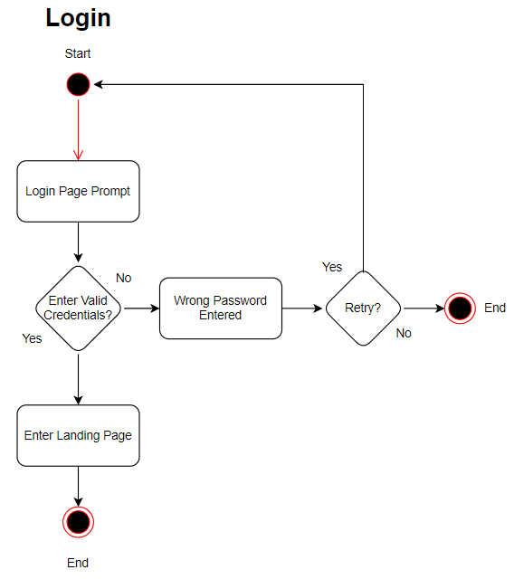

Template System
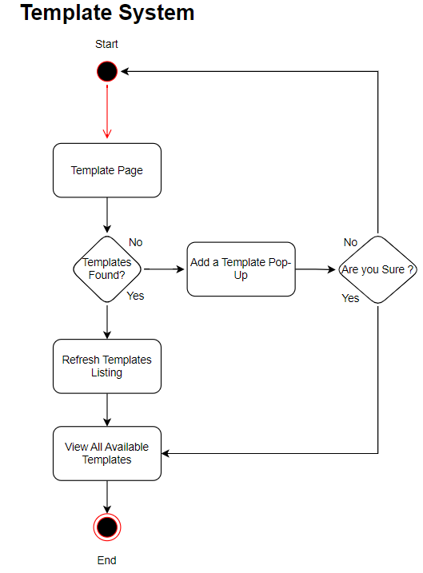

Submit Traveller
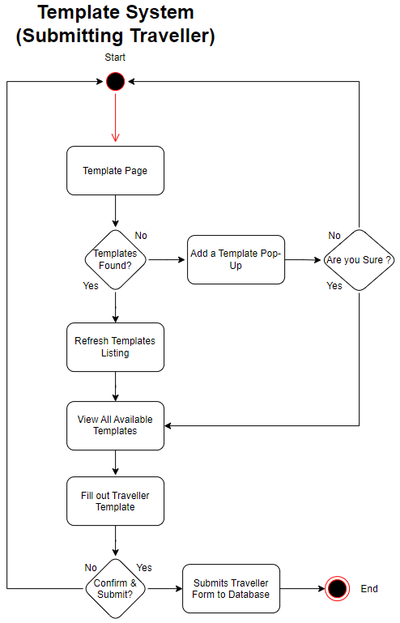

Traveller Revision
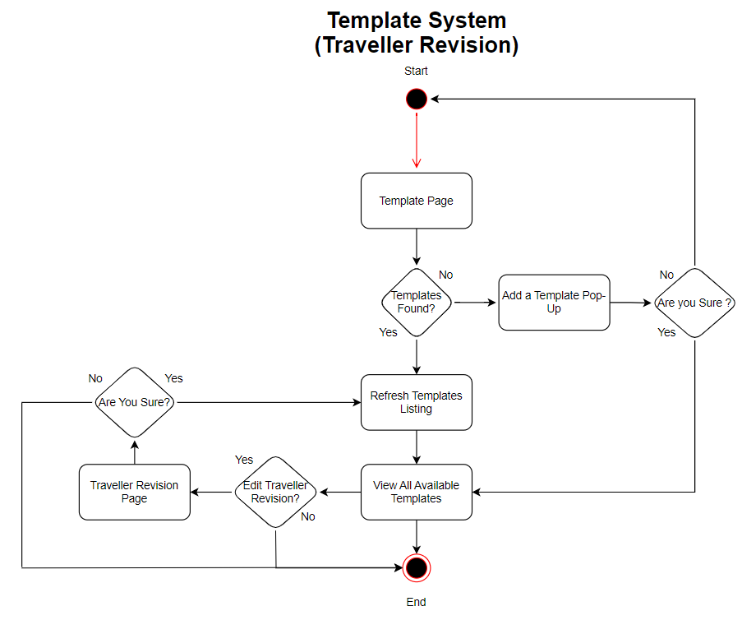

Use Case Diagram
Use Case Diagrams are a representation of users that use a system and belong to the system which also showcases how each individual user interacts with the system by declaring them with Actors. Use case diagrams are also used to display tasks within a system and how they can be completed. The following Use case diagram showcases how each user group would use the system being proposed. The use case diagram focuses on the two main groups that would be using the system, The Production Associate and the Head of Production i.e Management.
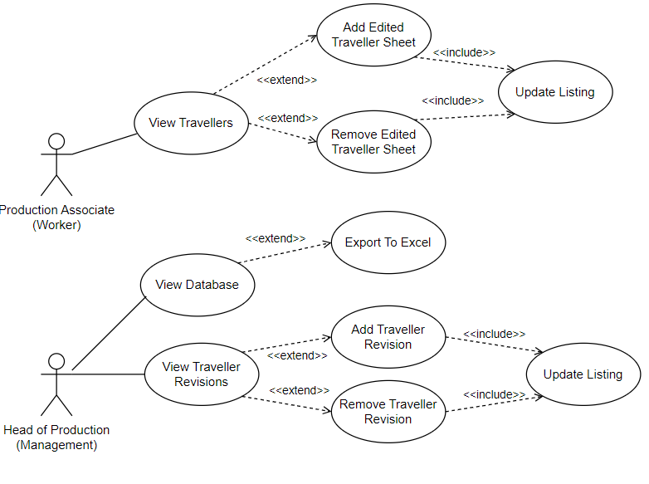

Sequence Diagram
Sequence Diagrams are used as a form of interaction and showcase on how tasks are completed within a system. They are used to contain the interaction between the objects and the system.

Login System
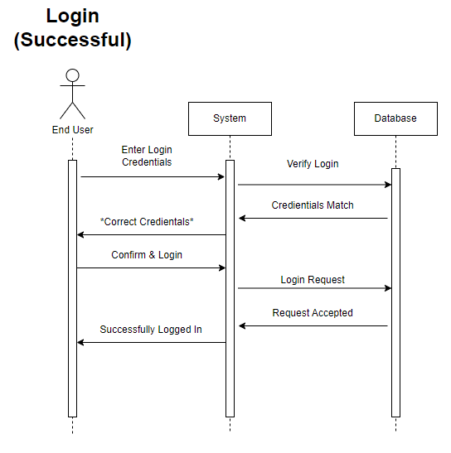
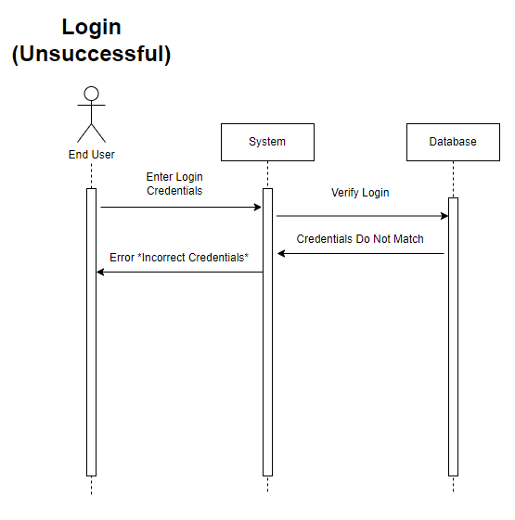

Traveller Submission
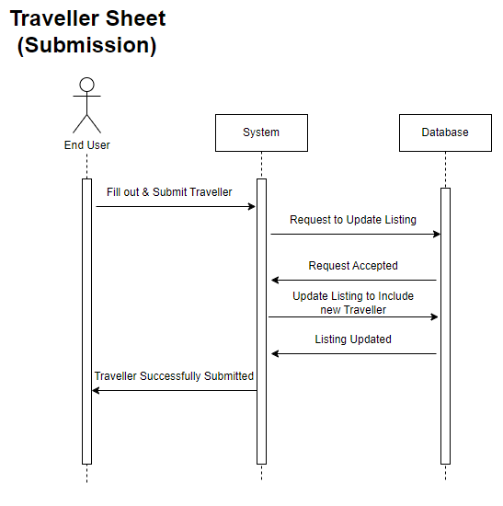

Traveller Revision
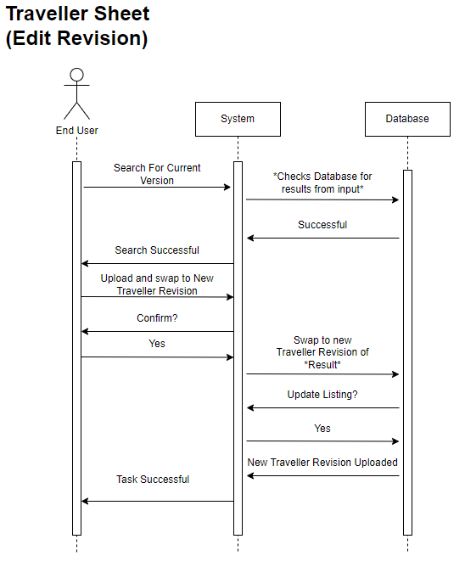

Class Diagrams
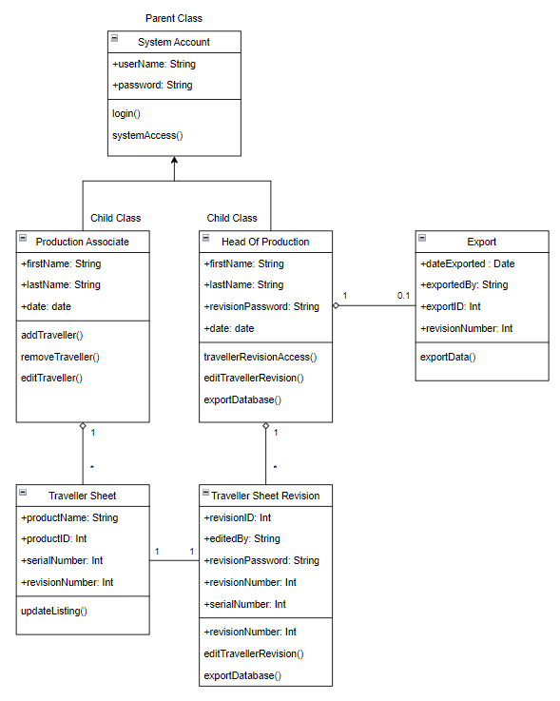

Entity Relationship Diagram
The Entity Relationship diagram provides insight on how entities within the proposed system will relate and function with each other. This Entity Relationship Diagram builds from my Class diagram discussed above to outline how the system will communicate with itself to function as expected.
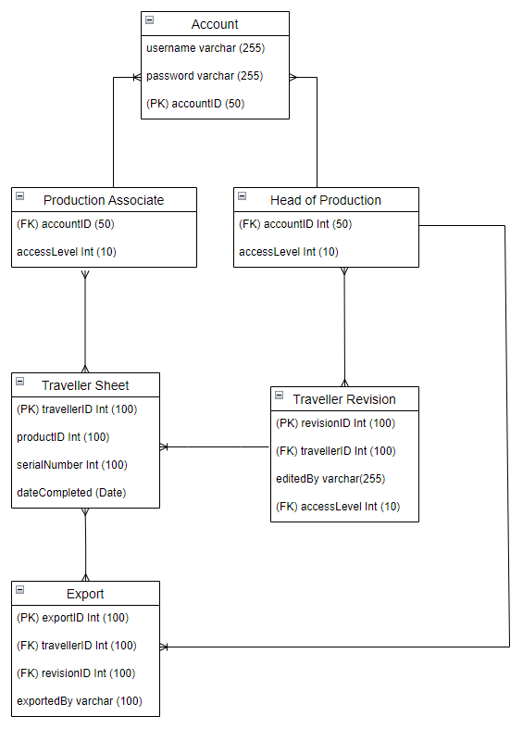

CRC Cards
The use of CRC Cards (Class Responsibility Collaborator) is for the purpose of visualizing the inner workings of a system mainly within object orientated systems. CRC Cards in the context of this project relate to the roles within MEP Technologies and such access they would have to the system.
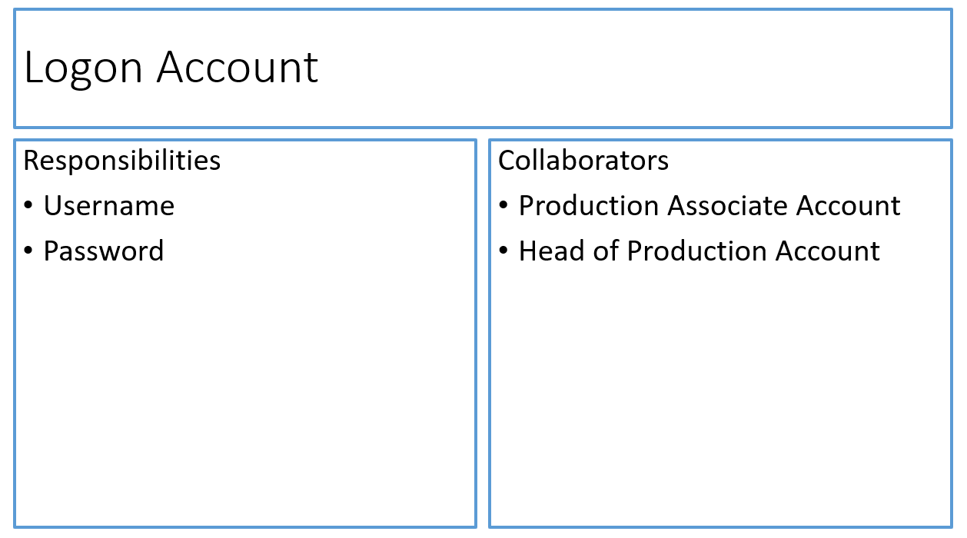
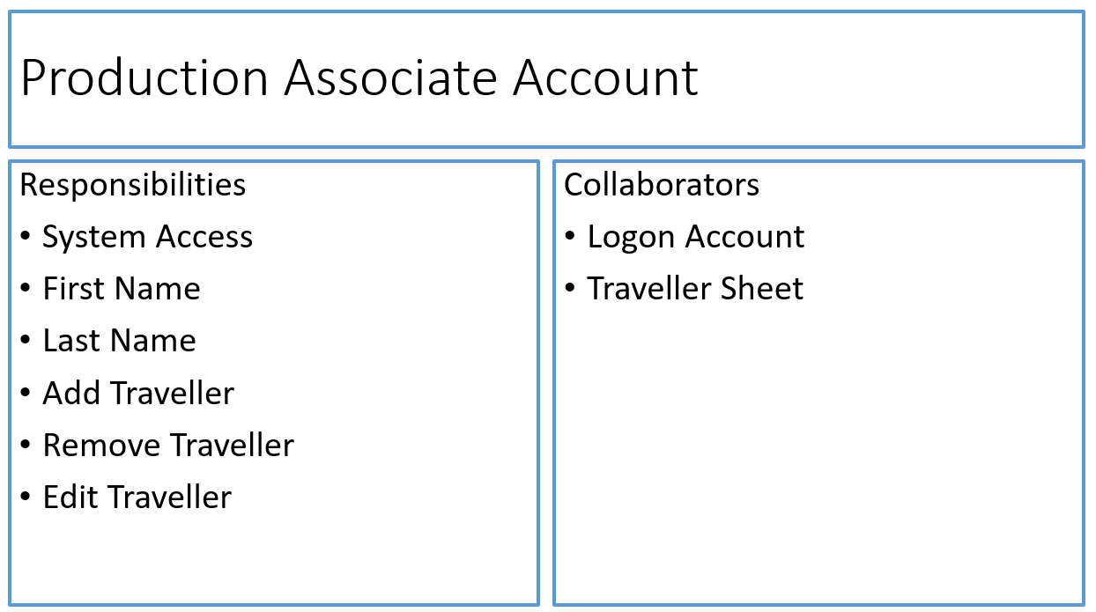
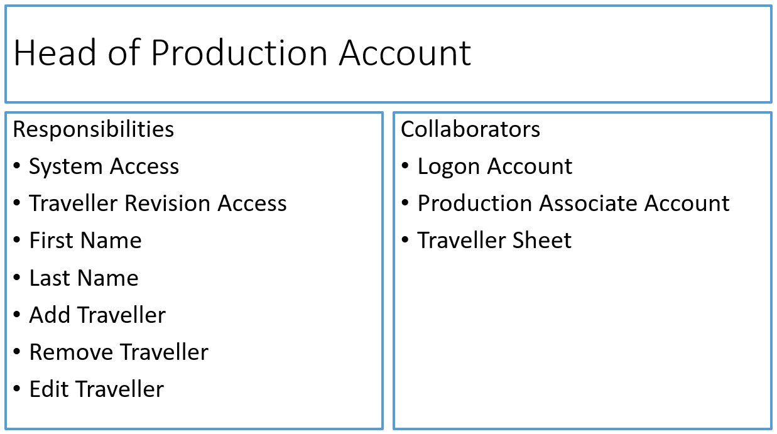
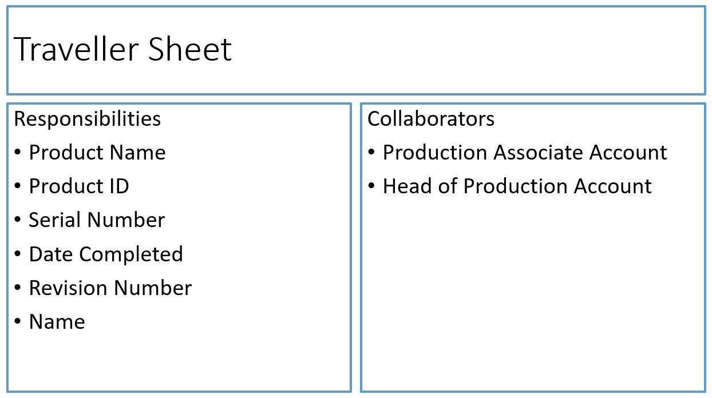

View Model

HCI
The 10 Heuristics of Usability is a carefully created procedure that showcases good practice guidelines created by Jakob Nielsen. The 10 Heuristics are applied to an application or system being developed when considering its design and overall usability not only for the developer, client but also the end user.

Visibility of System Status

Quote From Jakob Nielsen
“The design should always keep users informed about what is going on, through appropriate feedback within a reasonable amount of time.” (Nielsen, 2025)
Visibility of system status in implementation will be shown and displayed in the form of loading bars whether it’s implemented within the website/system or via the browser itself. The systems in theory should load data and information fast enough that loading bars or other forms of system status so they wouldn’t generally be required.

Match between System and Real world

Quote From Jakob Nielsen
The design should speak the users' language. Use words, phrases, and concepts familiar to the user, rather than internal jargon. (Nielsen, 2025)
Within the system as seen via wireframes proposed in the section below, Wording and naming aspects of the system are simplified allowing all users to easily understand what is going on in the system. This allows a wider range of users at the company to use the site that have a lesser technology background. Ensuring that jargon is simple to read and not complicated will lead to an overall better User Experience.

User Control and Freedom

Quote From Jakob Nielsen
Users often perform actions by mistake. They need a clearly marked "emergency exit" to leave the unwanted action without having to go through an extended process. (Nielsen, 2025)
With the creation of the wireframes for the initial system, I have taken User Control and Freedom Heuristic in mind, providing the end user with a final chance to exit out of a big action like Submitting a Traveller Sheet to the database or exporting the data to a file format, Providing the user with an “Are you sure” will allow the user to back out of unwanted actions that they may not have meant to click.

Consistency and Standards

Quote From Jakob Nielsen
Users should not have to wonder whether different words, situations, or actions mean the same thing. (Nielsen, 2025)
With the production of the wireframes for the system being proposed, ensuring that the whole system follows the same design choices and layout or similar will allow the end user to be able to use the application without having to learn multiple layouts per page. A simple design is a happy design which improves user experience overall.

Error Prevention

Quote From Jakob Nielsen
Good error messages are important, but the best designs carefully prevent problems from occurring in the first place. (Nielsen, 2025)
Error messages within the application are crucial to allow end users to improve their useability of a system, it’s certainly important to make sure error messages are fitting jargon the end user can understand and is not displayed to look worrying. The system proposed may not have much room for error but if it does happen would explain the issue, what happened and what they can do to resolve it.

Recognition Rather than Recall

Quote From Jakob Nielsen
Minimize the user's memory load by making elements, actions, and options visible. The user should not have to remember information from one part of the interface to another. (Nielsen, 2025)
Wireframe design choices are made to ensure that all designs are memorable for the end user, a simple design will allow them to use the system time and time again without having to constantly learn the system. This would relate to the elements of the wireframe design using buttons or other interactive elements, they all follow the same layout and jargon.

Flexibility and Efficiency of Use

Quote From Jakob Nielsen
Shortcuts — hidden from novice users — may speed up the interaction for the expert user so that the design can cater to both inexperienced and experienced users. (Nielsen, 2025)
Shortcuts allow for more experienced end users that have an extended knowledge of technology and using a keyboard for a computer to complete tasks slightly quicker or are more convenient to complete. Given that the system being proposed is mostly used in an Internet Browser, each browser comes with its own simplified shortcuts to be used, this can be simply used with my system providing less advanced users complete tasks the intended way whilst allowing more advanced users complete tasks how they wish.

Aesthetic and Minimalist Design

Quote From Jakob Nielsen
Interfaces should not contain information that is irrelevant or rarely needed. (Nielsen, 2025)
In creation of the wireframe designs, the main consideration is minimalist design, ensuring that a system displays content that is only relevant for its specific page that its on. Providing a user with incorrect or irrelevant information on a page that does not fit the purpose would confuse the end user which promotes a bad system. In relation to the wireframes that have been created, Traveller information is only displayed on a traveller page rather than a login page.

Recognise, Diagnose and Recover from Errors

Quote From Jakob Nielsen
Error messages should be expressed in plain language (no error codes), precisely indicate the problem, and constructively suggest a solution. (Nielsen, 2025)
As previously mentioned, ensuring that any and all error messages are set in clear wording and jargon for the end user to understand, in terms of my system if you enter the wrong login credentials instead of just saying “Error” it should go under the lines of or similar to “Error, you entered the wrong password” this gives the end user a clear point that the wrong password is entered allowing them to correct it and move on.

Help and Documentation

Quote From Jakob Nielsen
It’s best if the system doesn’t need any additional explanation. However, it may be necessary to provide documentation to help users understand how to complete their tasks. (Nielsen, 2025)
A Well-designed system is a happy and useful system not only for the developer but the end user. Ensuring that documentation relating to the system and all guides are available for the end user is crucial as you do not know who exactly will end up using the system. Providing the end user with a step-by-step guide on how exactly it should be used will aid users in using the system more.

Wireframes

Login Page
The Login Page is the first screen a user is met with in attempt to access the system, consists of a simplified login screen prompting a username and password input from the end user, these credentials would be issued by the IT Department of MEP Technologies or Developer Themselves to ensure no unauthorize entry, due to this the design is highly minimal.
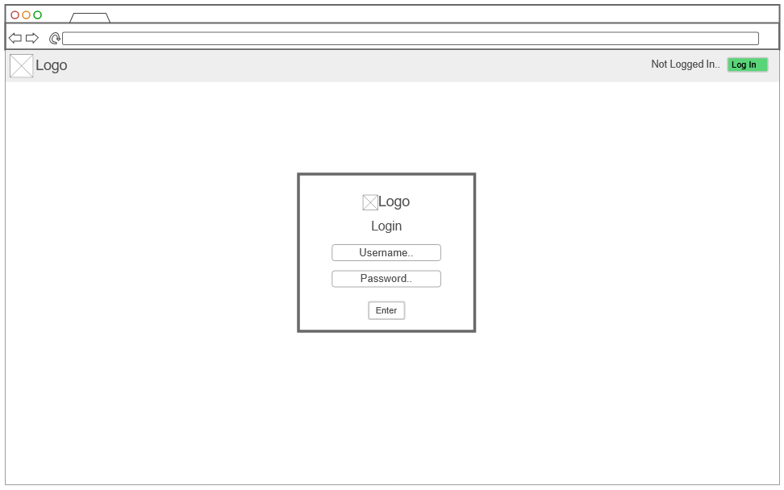

Select Traveller
Traveller Templates Page: Selecting Traveller, Page dedicated to a selection of traveller sheets to fill out. End users would be met with this page upon logging into the system. These Traveller Template Wireframes are under the conditions of being logged in as Head of Production and thus options of Viewing and Editing Traveller Revisions are visible.
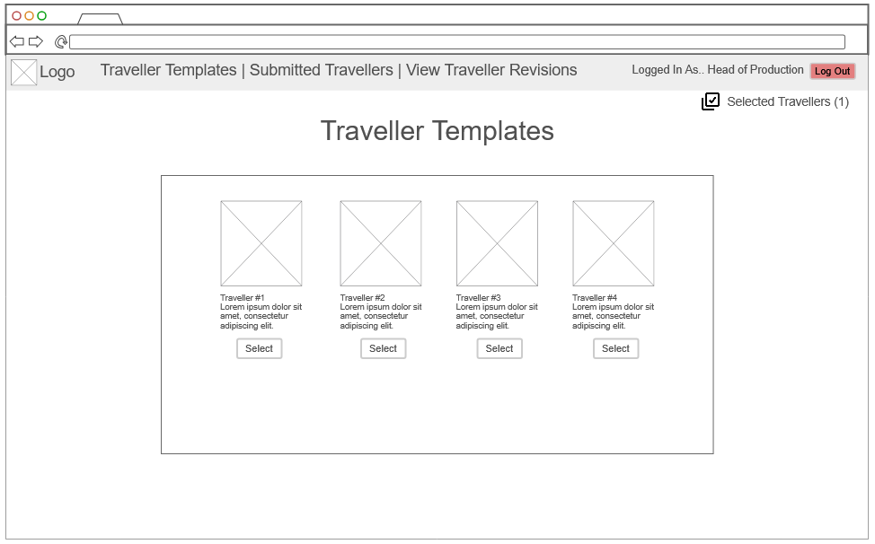

Edit Traveller
The Edit Traveller Page will allow Production Associates to Fill out the traveller sheet by clicking on the respective sections completed, the system will automatically fill out the date of the traveller sheet being completed; Additionally, a confirmation menu will appear beforehand allowing the associate with a final chance to cancel the action before it being sent.
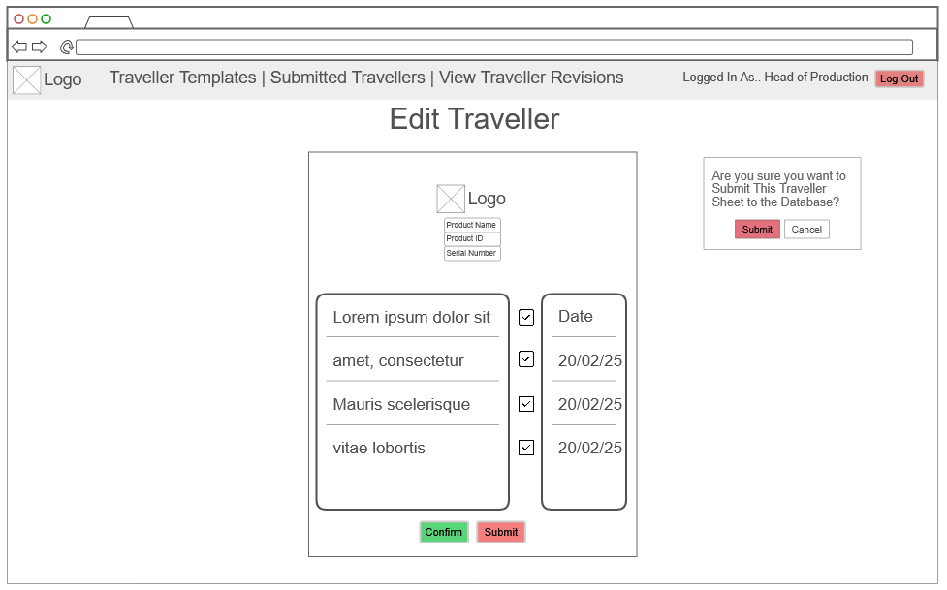

Edit Traveller Revision
The Edit Traveller Revision page will provide a simplified experience for Upper Management to easily edit currently live Revisions of Traveller Sheets through the Edit Traveller Revision page. With the similar layout of Edit Traveller it provides a 1:1 experience which does not require much extra learning on how to complete this task.
The Edit Traveller Revision aspect will provide a simplified experience for Upper Management to easily edit currently live Revisions of Traveller Sheets through the Edit Traveller Revision page. With the similar layout of Edit Traveller it provides a 1:1 experience which does not require much extra learning on how to complete this task; Additionally this comes with a confirm menu to ensure management are correct and they do want to swap to a new Traveller Revision.

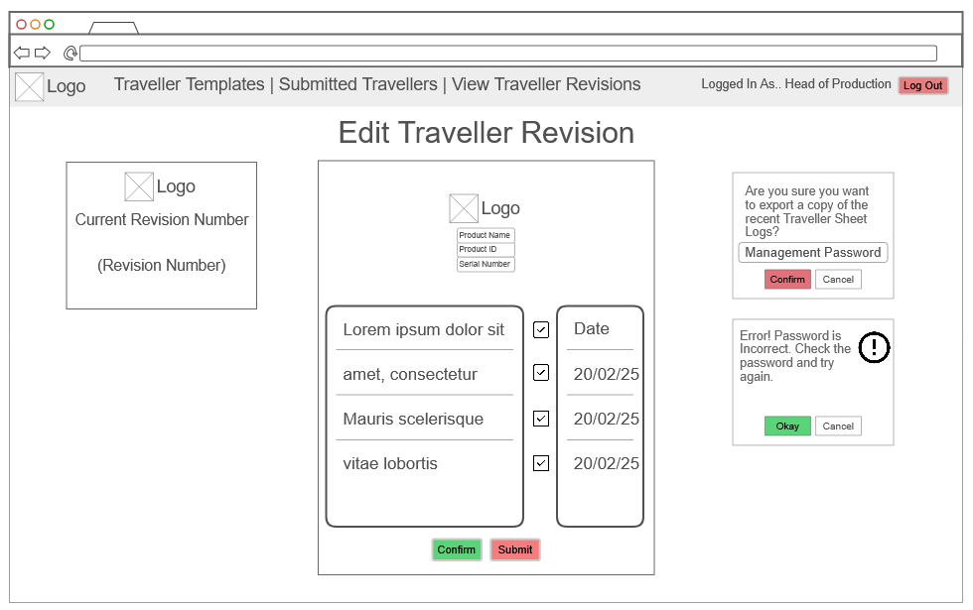

Export Traveller Logs
Traveller Sheet Log Page is a simple page dedicated to display all recent submitted traveller sheets to the database, it will automatically display all recent travellers into this page which management with the use of a management password can export it to a file of a few formats to choose from for example Excel.
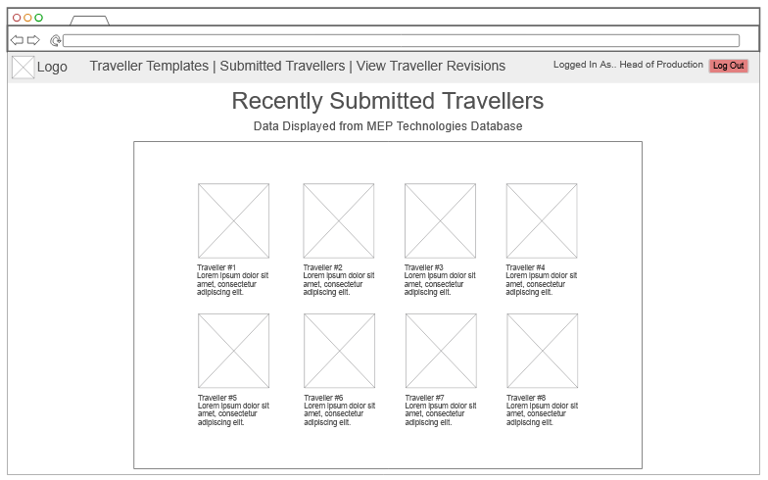

Confirm Export Traveller Logs
Traveller Sheet Log Page is a simple page dedicated to display all recent submitted traveller sheets to the database, it will automatically display all recent travellers into this page which management with the use of a management password can export it to a file of a few formats to choose from for example Excel; Additionally a confirmation menu will appear beforehand allowing the end user ample opportunity to back out of this decision before its completed.
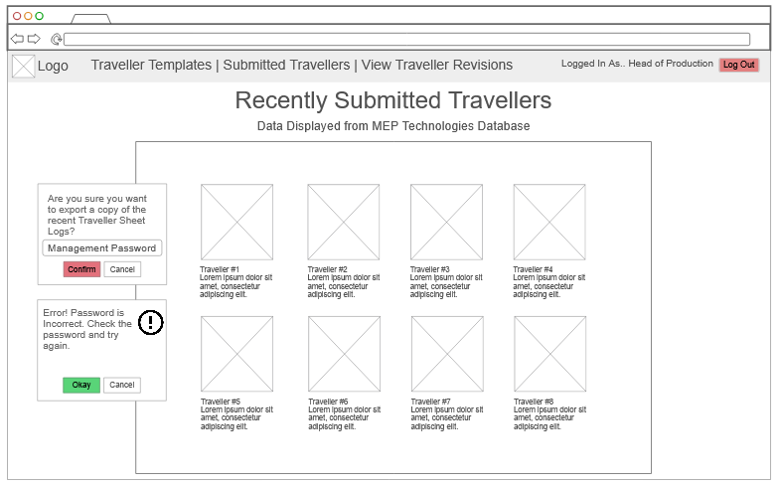

Data Binding
The following data binding diagrams show a view on how pages interact with the classes being used within them to gain a better understanding on how it will function in the background/backend.

Account Login
The login page will interact with the account, Logging into an account with specific credentials will find you access to one of two accounts, Production Associate or Head of Production, Head of production may have more permissions within the system than Associate i.e exporting data & pushing new traveller revisions.
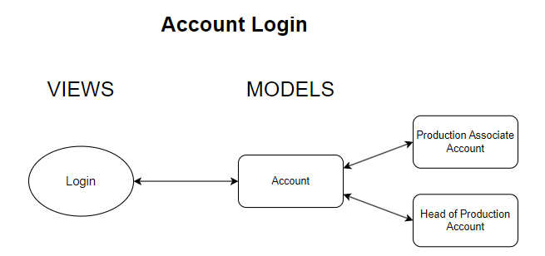

Editing Traveller
On the basis of the diagram, the logged in account is Production Associate. The Editing traveller page will interact with the Account & Traveller Sheets in order to load the correct traveller the end user has selected via retrieving data from the database on the basis of the traveller chosen.
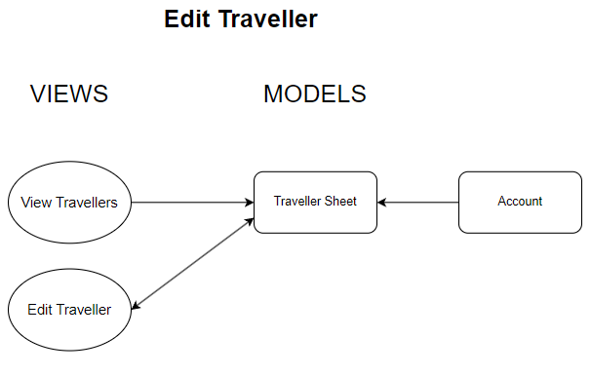

Editing Traveller Revision
Viewing Traveller & Editing the traveller revision both exist within the edit traveller revision page, data retrieved from the traveller sheet model, which is retrieved from the database, once updated will update the listing. Editing Traveller Revision is only possible with the Head of Production Authorisation.
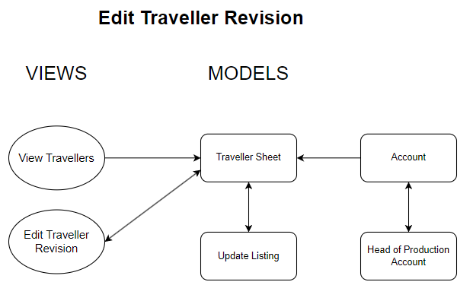

Export Traveller Data
Addendum to Editing the traveller Revision, Exporting Traveller Data will run through the same page but only will appear if Head of Production Account is logged in, Selected traveller data will be pulled from the traveller sheet page and database to be exported.
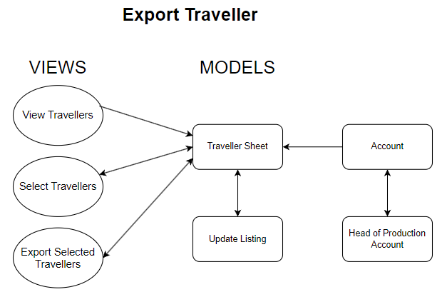

Bibliography
Custom Battery Systems . (2024). Custom Battery Systems. [online] Available at: https://meptec.co.uk/ [Accessed 11 Feb. 2025].
Acunetix. (2017). What is SQL Injection (SQLi) and How to Prevent It. [online] Available at: https://www.acunetix.com/websitesecurity/sql-injection/.
Nielsen, J. (2024). 10 Heuristics for User Interface Design. [online] Nielsen Norman Group. Available at: https://www.nngroup.com/articles/ten-usability-heuristics/.
Agile Modeling. (n.d.). Class Responsibility Collaborator (CRC) Models: An Agile Introduction – The Agile Modeling (AM) Method. [online] Available at: https://agilemodeling.com/artifacts/crcmodel.htm.
‌

